Assignment 2
Student id: a1905899 student name: Haoxiang Wen(Will)

Introduction
This document aims to show some basic tests and output of project. For some reason the autograder can not recognize the files in master branch of project when submit by github. So I made this file to show some test cases and their outputs.

Test cases:
(aggregation server is always the first one running)
1: when there is no local weather data in aggregation server
Get client:
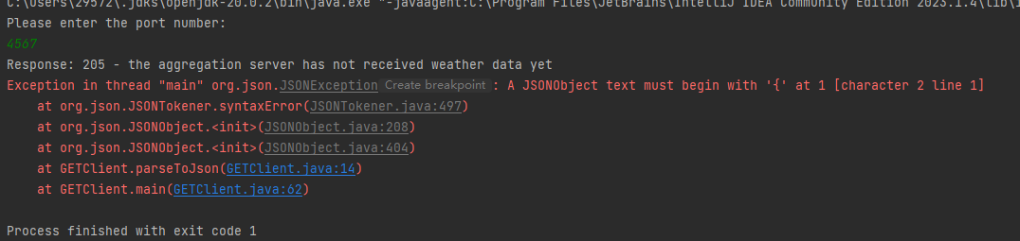
Get client will exit and print relevant response

2: when the content server input wrong port number
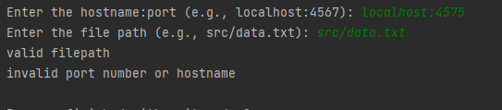
The content server will receive two parameters, one is hostname:port the other one is filepath.

3: when content server input wrong filepath
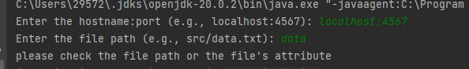
In this case there is something wrong with error message, it will also display “invalid port number of hostname”

4:when content server successfully send PUT request and data to aggregation server for the first time
content server:
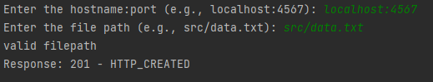
The content server will receive a response

Aggregation server:
The aggregation server will display the data and show request type

5:when content server send PUT request and data to update

Content server:
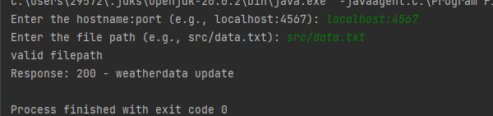

6: when client input wrong port number:
Get client
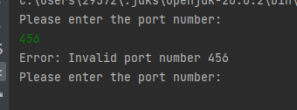

7: when client successfully send GET request:
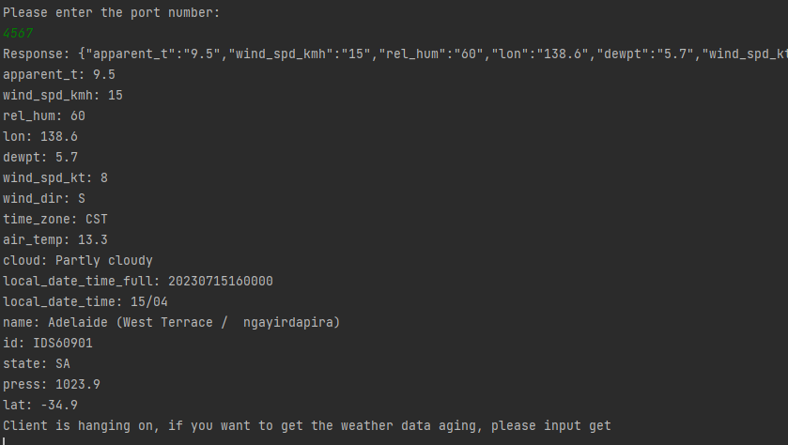
It will display weather data

8: if client wants to get data again
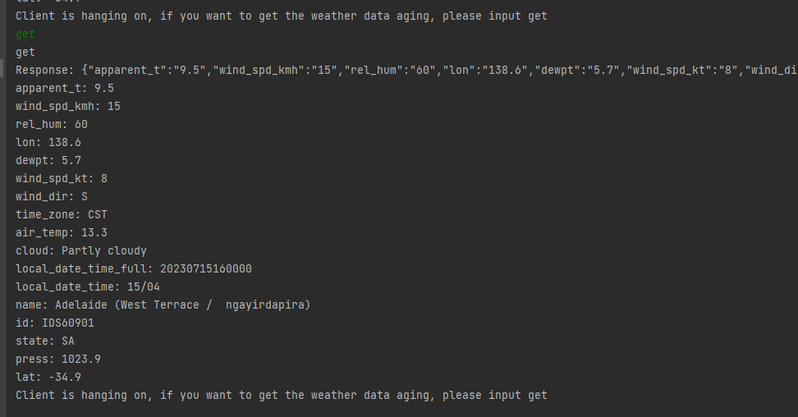

9:if client does not do anything for 30 seconds:
